Art and Photography A2 Personal Study guidelines
Welcome to your A2 year! This year you will complete a written Personal Study alongside your practical work. Your Personal Study and your coursework sketchbook need to be about the same subject matter. You will first chose a broad area of focus for your coursework project that you wish to pursue, eg ‘Mystery and Imagination’ or ‘Transformation’. You will then think of an interesting question that you will answer through your essay that also relates to this word or topic.
Marking
The essay you produce will go towards your coursework grade with the usual sketchbook and final piece. Your teacher will mark the essay and return it to you with feedback at least once before the final submission.
Format
The personal study will consist of a critical and analytical written piece of a minimum 1000 words continuous prose, (although the average is 2000-4000 words) making links to your own practical investigations, supported by contextual research. Each section will demonstrate your understanding of relevant social, cultural or historical contexts. You will also express personal interpretations or conclusions, and use specialist vocabulary.
  - Title (not included in word count)
  - Rationale (not included in word count – approx. 100 words)

  - Contextual Introduction (min 100 words)
  - Artist 1 (min 150 words)
  - Artist 2 (min 150 words)
  - Artist 3 (min 150 words)
  - Artist 4 (min 150 words)
  - Artist 5 (min 150 words)
  - Comparisons (done within the above 5 sections)
  - Conclusion (min 150 words)

  - Bibliography (not included in word count)
This framework guides you on what you need to write, and roughly how many words on each section. This framework is quite basic and is aimed to be a support to the development of your essay. You do not have to stick to the word limit on each section, nor do you only have to answer these questions. You may have other areas you wish to discuss, or other questions you want to answer. Every essay will be different and personal to you and your project. Choose something you are interested in and try to enjoy it!
  - Title
The title of your investigation must relate to your body of practical coursework. It may help you to look back over past exam papers to search for themes that you are interested in. Once you have decided on your topic of interest, try to phrase it into a open-ended question as your title. This will give you the opportunity to use your essay to answer it. Here are some examples:
- Eg. How do illustrators use a range of processes and techniques to create
imaginative characters and storylines?
- Eg. How do contemporary street artists explore the theme of ‘Self’ and how does
their identity or political views affect their work?
- Eg. How do contemporary artists convey obsessions and compulsions in their
work?
- Eg. How is the theme of stereotyping explored by artists and what impact does
stereotyping have on artists and their work?
- Eg. How have artists explore the theme of captivation through a variety of media
and eras?

  - Rationale
- What is this essay going to be about?
- Why are you interested in answering this question?
- Why are you interested in this subject matter?
- What are you hoping to find out/learn more about?
- What sort of work are you hoping to make as part of your coursework project?
- Are there any particular ideas, themes, processes, techniques you are interested in exploring?
- What artists work are you going to be exploring in this essay?
- What interests you about these artists? How do they link to your ideas/work?

  - Contextual Introduction (min 100 words)
- What is your theme about?
- Can you quote a definition? Use a dictionary to clarify the meaning of your chosen word/theme.
- Who is involved in this area? Are their any particular people/artists involved?
- What have they been quoted saying on this topic?
- How does it relate to our environment/ engagement with the world?
- What connections does it make to other areas e.g. architecture, politics, countries, our surroundings?
- Who does it relate to and how?
- What impact does it have on you/others?
- Is it something we experience? How?
- What artists work are you going to be exploring in this essay?
- What interests you about these artists? How do they link to your ideas/work?

  - Artist 1 (min 150 words)
Write an artist analysis using the usual questions on the ‘Looking at Artists and Their Work’ framework. Remember to add relevant images.

  - Artist 2 (min 150 words)
Write an artist analysis using the usual questions on the ‘Looking at Artists and Their Work’ framework. Remember to add relevant images.

  - Artist 3 (min 150 words)
Write an artist analysis using the usual questions on the ‘Looking at Artists and Their Work’ framework. Remember to add relevant images.

  - Artist 4 (min 150 words)
Write an artist analysis using the usual questions on the ‘Looking at Artists and Their Work’ framework. Remember to add relevant images.

  - Artist 5 (min 150 words)
Write an artist analysis using the usual questions on the ‘Looking at Artists and Their Work’ framework. Remember to add relevant images.

2.7 Comparisons

This should happen throughout your five artist essays. You should have picked a range of artists who are all relevant to your theme, but have approached it in different ways.

- How have the artists you have looked at explored your subject matter similarly and differently?
- Discuss and compare and contrast their different approaches.
- Give your opinions. It could be they use similar/different materials, explore similar ideas, use similar techniques and processes etc.
- Think about how their work interlinks and how it can also be about the same topic, yet look at from different angles.

2.8 Conclusion (min 150 words)

- What have you learnt from writing this essay or how have your opinions changed?
- Are you better informed about your subject matter?
- Do you feel you have answered the question you set out to? You may not have a direct answer, but reiterate and weigh up the conclusions that you have drawn throughout the essay, explaining what your final opinion is.
- How is this research and your understanding of this topic going to help you with your practical work?
- What ideas do you have for the development of your of your work?

  - Bibliography

It is important that you write in your own words and reference any sources that you have used. The bibliography is a list of all the references that you have used, in alphabetical order. Please see overleaf for the referencing guide on how to do this.

Referencing

Referencing is a format which helps you to tell the reader what sources you have used.

You can read more about how to reference by using Google, but here is a summary of some of the main points:

- All quotations are indented, with no speech marks and sources are referenced with a superscript number.
- Footnotes are on every page.
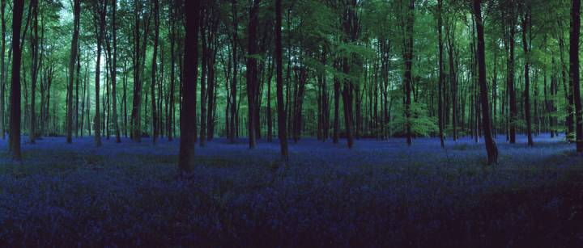
- Authors are credited with their last name first, then first initial. (Publication date in brackets). Book title in italics. Additional information. City of publication: Publishing company
Figure 1: Chrystel Lebas, 'Blue Hour, Untitled 7' 2006
- Pictures have figure numbers, and each picture must be referenced (see right for example).
- Websites must be referenced with the date on which they were used, as content can change with time.

Presentation of the Personal Study
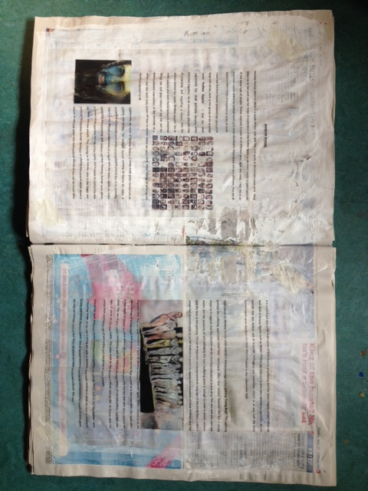
You may wish to support your progress in writing with visual examples of your own work and the work of others, sketchbook annotation, notes from visits, exploration of materials and the development of your own ideas. You may wish to present your essay in a creative format that matches your title - be imaginative with how you use your materials in relation to your title!

Footnotes go at the end of every page, not at the end of the whole document.
eg Boorstin, D. (1992). The creators: A history of the heroes of the imagination. New York: Random House.
eg http://www.tate.org.uk/visit/tate-modern?gclid=CKmgnevCgMYCFSnMtAodHVMAFA (seen on 8/6/15)

