National Curriculum Levels | FORM III | LOWER IV | UPPER IV
L2 | 5 - BASIC
L3 | 4 - LIMITED | 5 BASIC
L4 | 3 - COMPETENT | 4 LIMITED | 5 BASIC
L5 | 2 - CONFIDENT | 3 COMPETENT | 4 LIMITED
L6 | 1 - FLUENT | 2 CONFIDENT | 3 CONPETENT
L7 |  | 1 FLUENT | 2 CONFIDENT
L8 |  |  | 1 FLUENT
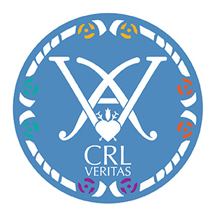
Insert about EP level
Know how to progress

Relate to Edexcel words

ART DEPARTMENT
LEVEL DESCRIPTORS
KEY STAGE 3

