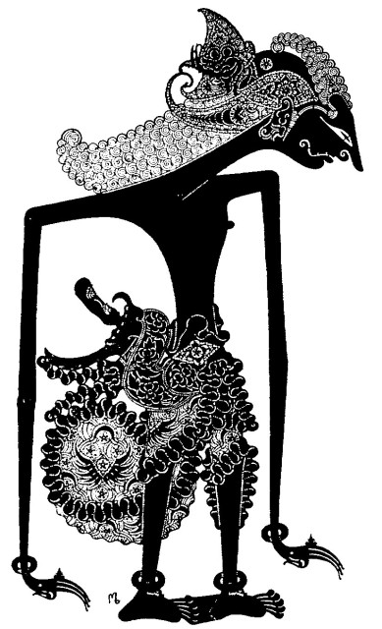

**Balinese Shadow Puppet**