EXPRESSIVE FACES PROJECT EVALUATION

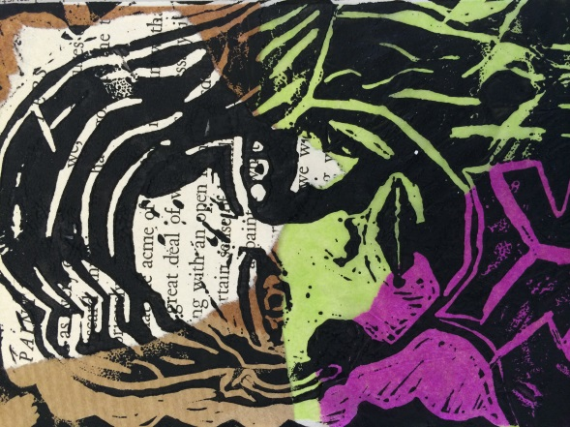
- Which print is best and why?

- What background were you most pleased with and why?

- How well does your work relate to the German Expressionist artists you have studied?

- How successful were you in transferring your image to the lino material?

- Were you pleased with your portrait image, or would you do anything differently?

- What did you learn from the lino-printing process?

