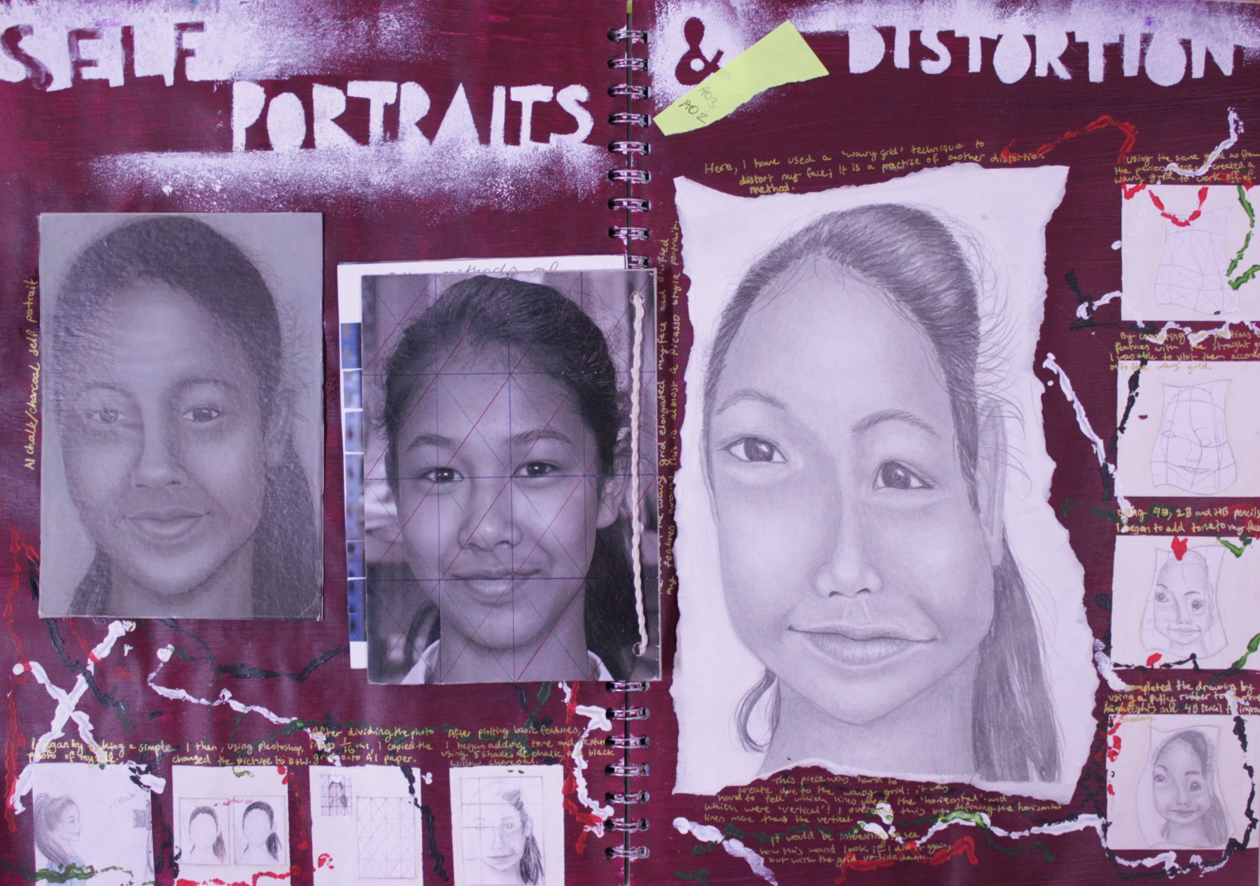
USING A WAVY GRID TO DISTORT YOUR PORTRAIT Cover Lesson: Upper IV Alpha; Period 1 Tuesday 21st October 2014
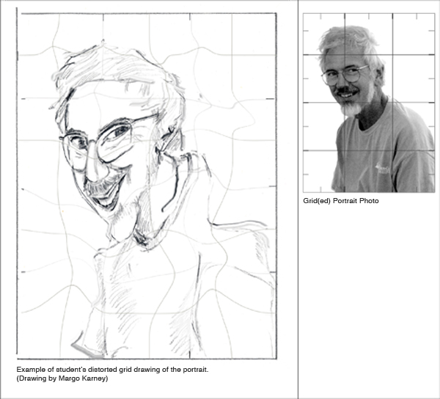

Here are some examples of previous students’ artwork using a distorted, wavy grid.
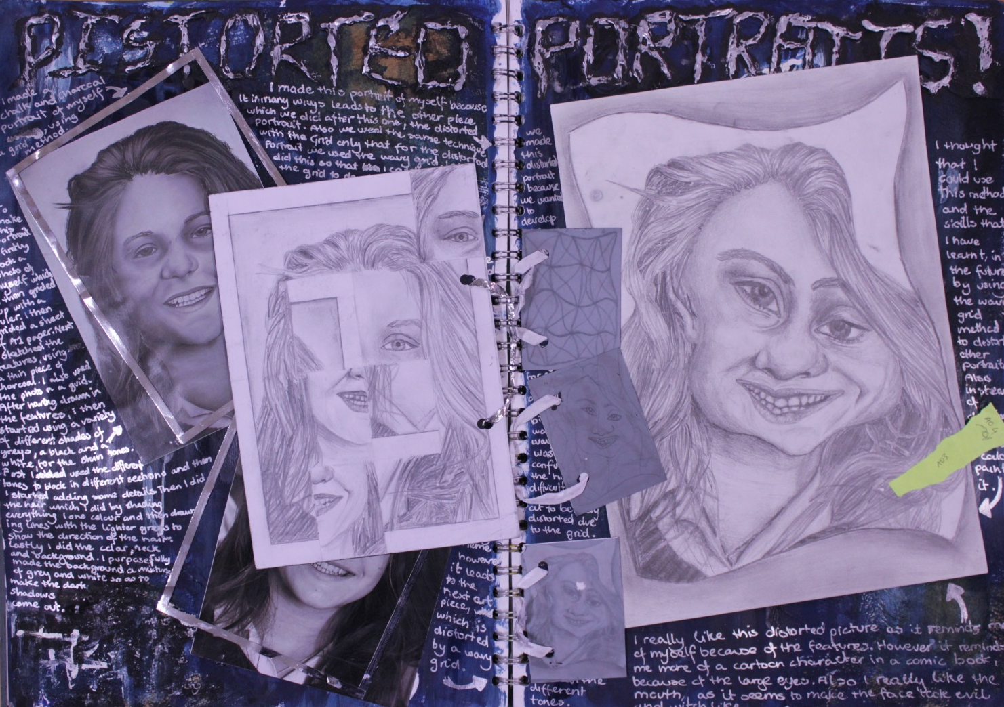
TASK:
In this cover lesson I would like you to use the grid method to distort your portrait. In order to do this you must create a ‘wavy’ grid that has the same number of squares as your accurate grid that is drawn over your portrait. You must then plot your features and face shape accurately on the new grid. This will create a distortion of your face.
STEP 1: Count the number of horizontal and vertical lines you need to draw on your paper
STEP 2: Draw a new grid on the paper with the right number of lines but make your lines wavy.
STEP 3: Accurately plot each feature and your face shape until you build up a distorted self-portrait line drawing
STEP 4: Finish with a wide range of tone and fine detail

